Diameter Equality
# Source: AI Source: Provided by: [Data Path: Persons Table -> ID Column: 1, Name_En Column: Motasem Essam] -> From: [ChatGPT] on [7/25/2026]
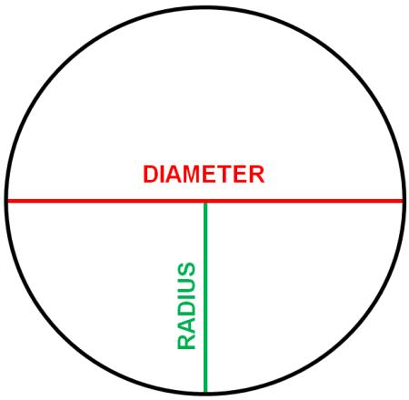
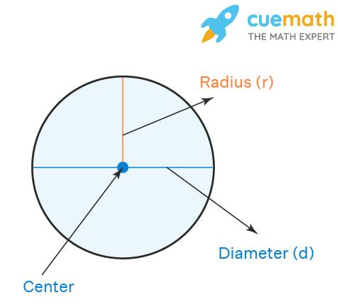
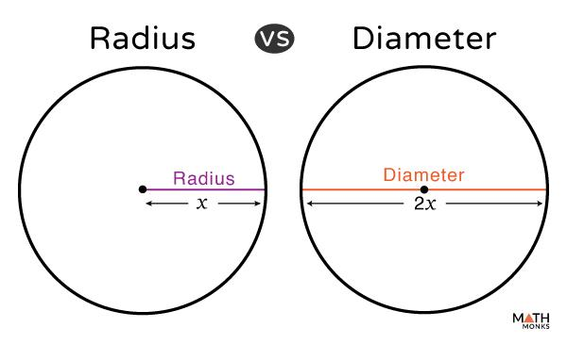
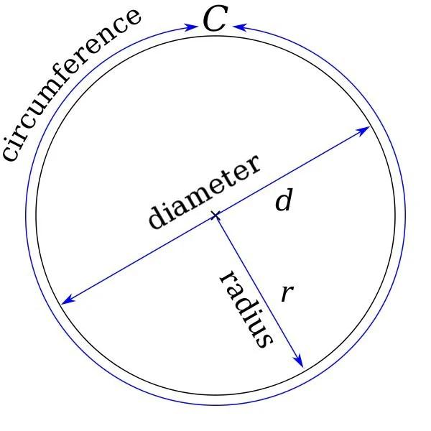
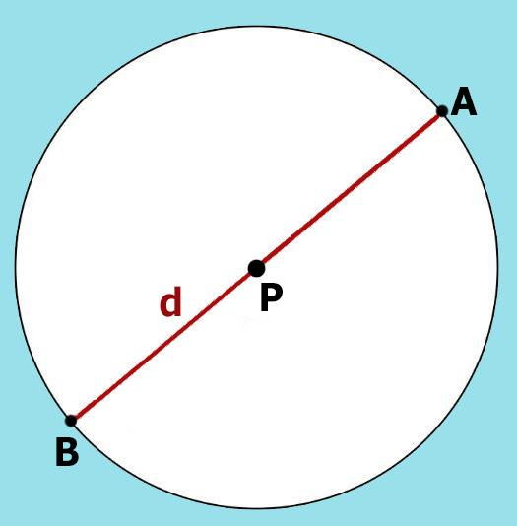

Definition
# Source: AI Source: Provided by: [Data Path: Persons Table -> ID Column: 1, Name_En Column: Motasem Essam] -> From: [ChatGPT] on [7/25/2026]
Diameter Equality is an exact geometric relationship in which two or more circles, or two or more diameters, have equal diameter lengths.
For two circles with diameters $d_{1}$and $d_{2}$:
$$\boxed{d_{1}=d_{2}}$$
A diameter is a line segment passing through the center of a circle with both endpoints on the circle.
For a circle with radius $r$:
$$\boxed{d=2r}$$
Therefore, diameter equality is directly related to radius equality:
$$\boxed{d_{1}=d_{2} ⟺ r_{1}=r_{2}}$$

Simple Definition
# Source: AI Source: Provided by: [Data Path: Persons Table -> ID Column: 1, Name_En Column: Motasem Essam] -> From: [ChatGPT] on [7/25/2026]
Diameter Equality means that two or more circles have exactly the same diameter length.
For example, if:
$$d_{1}=10\text{ cm}$$
and:
$$d_{2}=10\text{ cm},$$
then:
$$\boxed{d_{1}=d_{2}}.$$

Fundamental Concept
# Source: AI Source: Provided by: [Data Path: Persons Table -> ID Column: 1, Name_En Column: Motasem Essam] -> From: [ChatGPT] on [7/25/2026]
The diameter is twice the radius:
$$\boxed{d=2r}$$
Therefore:
$$\boxed{d_{1}=d_{2}}$$
means:
$$2r_{1}=2r_{2}$$
and hence:
$$\boxed{r_{1}=r_{2}}.$$
Thus, for circles:
$$\boxed{\text{Diameter Equality }⟺\text{ Radius Equality}}$$
Diameter equality also implies equal circumferences and equal areas for circles:
$$d_{1}=d_{2}⇒r_{1}=r_{2}⇒C_{1}=C_{2}⇒A_{1}=A_{2}.$$

Classification of Diameter Equality
# Source: AI Source: Provided by: [Data Path: Persons Table -> ID Column: 1, Name_En Column: Motasem Essam] -> From: [ChatGPT] on [7/25/2026]
A practical classification is:
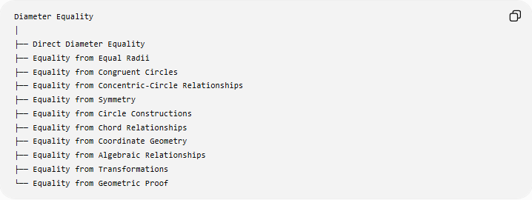
Diameter Equality
│
├── Direct Diameter Equality
├── Equality from Equal Radii
├── Equality from Congruent Circles
├── Equality from Concentric-Circle Relationships
├── Equality from Symmetry
├── Equality from Circle Constructions
├── Equality from Chord Relationships
├── Equality from Coordinate Geometry
├── Equality from Algebraic Relationships
├── Equality from Transformations
└── Equality from Geometric Proof
This is a practical classification rather than a universally standardized formal taxonomy.

Direct Diameter Equality
# Source: AI Source: Provided by: [Data Path: Persons Table -> ID Column: 1, Name_En Column: Motasem Essam] -> From: [ChatGPT] on [7/25/2026]
Definition
The diameters are directly given as equal:
$$\boxed{AB=CD}$$
where $AB$and $CD$are diameters of two circles.
Example
Circle $C_{1}$:
$$d_{1}=12\text{ cm}$$
Circle $C_{2}$:
$$d_{2}=12\text{ cm}.$$
Therefore:
$$\boxed{d_{1}=d_{2}}.$$

Equality from Equal Radii
# Source: AI Source: Provided by: [Data Path: Persons Table -> ID Column: 1, Name_En Column: Motasem Essam] -> From: [ChatGPT] on [7/25/2026]
Since:
$$d=2r,$$
equal radii produce equal diameters.
If:
$$r_{1}=r_{2},$$
then:
$$2r_{1}=2r_{2}$$
and therefore:
$$\boxed{d_{1}=d_{2}}.$$
Example
Circle A:
$$r_{A}=7\text{ cm}$$
Circle B:
$$r_{B}=7\text{ cm}.$$
Therefore:
$$d_{A}=2\left(7\right)=14\text{ cm}$$
and:
$$d_{B}=2\left(7\right)=14\text{ cm}.$$
Thus:
$$\boxed{d_{A}=d_{B}=14\text{ cm}}.$$

Equality from Congruent Circles
# Source: AI Source: Provided by: [Data Path: Persons Table -> ID Column: 1, Name_En Column: Motasem Essam] -> From: [ChatGPT] on [7/25/2026]
Definition
Two congruent circles have equal radii and therefore equal diameters.
$$\boxed{C_{1}≅C_{2}⇒d_{1}=d_{2}}$$
Example
If:
$$C_{1}≅C_{2}$$
and:
$$r_{1}=r_{2}=5,$$
then:
$$d_{1}=d_{2}=10.$$
Therefore:
$$\boxed{d_{1}=d_{2}}.$$
For circles, equal diameters also imply congruent circles:
$$\boxed{d_{1}=d_{2} ⟺ C_{1}≅C_{2}}.$$

Equality Among Multiple Diameters of One Circle
# Source: AI Source: Provided by: [Data Path: Persons Table -> ID Column: 1, Name_En Column: Motasem Essam] -> From: [ChatGPT] on [7/25/2026]
A particularly important property of a circle is that all diameters of the same circle have equal length.
If $AB$and $CD$are both diameters of the same circle:
$$\boxed{AB=CD}$$
Example
If circle $O$has radius $6$cm, then every diameter has length:
$$d=2\left(6\right)=12\text{ cm}.$$
Thus:
$$\boxed{AB=CD=EF=12\text{ cm}}$$
for any diameters $AB,CD,EF$of that circle.
Important distinction
The diameters may have different directions, but their lengths are equal.

Equality from Opposite Endpoints
# Source: AI Source: Provided by: [Data Path: Persons Table -> ID Column: 1, Name_En Column: Motasem Essam] -> From: [ChatGPT] on [7/25/2026]
If $AB$is a diameter, the center $O$is its midpoint:
$$AO=OB$$
and:
$$AB=AO+OB.$$
Since:
$$AO=OB=r,$$
we obtain:
$$\boxed{AB=2r}.$$
Example
If:
$$AO=OB=4\text{ cm},$$
then:
$$AB=4+4=8\text{ cm}.$$
Therefore:
$$\boxed{AB=8\text{ cm}}.$$

Equality from Concentric-Circle Relationships
# Source: AI Source: Provided by: [Data Path: Persons Table -> ID Column: 1, Name_En Column: Motasem Essam] -> From: [ChatGPT] on [7/25/2026]
Concentric circles share the same center but generally have different radii.
If two concentric circles have:
$$r_{1}=r_{2},$$
then:
$$d_{1}=2r_{1}, d_{2}=2r_{2}.$$
Therefore:
$$\boxed{d_{1}=d_{2}}.$$
However, if two concentric circles are distinct, then their radii must be different:
$$r_{1}≠r_{2}$$
and consequently:
$$d_{1}≠d_{2}.$$
So concentricity alone does not imply diameter equality.

Diameter Equality from Symmetry
# Source: AI Source: Provided by: [Data Path: Persons Table -> ID Column: 1, Name_En Column: Motasem Essam] -> From: [ChatGPT] on [7/25/2026]
Symmetry can establish equal diameters or equal diameter-related segments.
For example, reflection across a diameter maps one semicircle onto the other. Since reflection preserves distance, corresponding diameter-related segments have equal lengths.
More generally:
$$\boxed{\text{Isometry}⇒\text{Length Preservation}}$$
and therefore diameter length is preserved.

Diameter Equality from Transformations
# Source: AI Source: Provided by: [Data Path: Persons Table -> ID Column: 1, Name_En Column: Motasem Essam] -> From: [ChatGPT] on [7/25/2026]
An isometry preserves lengths.
The main plane isometries are:
- Translation
- Rotation
- Reflection
- Glide reflection
If a circle with diameter $d$is transformed by an isometry, its image circle has the same diameter:
$$\boxed{d^{'}=d}.$$
Example
A circle has:
$$d=8\text{ cm}.$$
After a rotation:
$$d^{'}=8\text{ cm}.$$
Therefore:
$$\boxed{d=d^{'}}.$$

Diameter Equality from Scaling
# Source: AI Source: Provided by: [Data Path: Persons Table -> ID Column: 1, Name_En Column: Motasem Essam] -> From: [ChatGPT] on [7/25/2026]
Scaling behaves differently.
If a circle is enlarged by scale factor $k$:
$$\boxed{d^{'}=kd}$$
and:
$$\boxed{r^{'}=kr}.$$
Therefore, two scaled circles have equal diameters only if:
$$\boxed{kd=d}$$
which, for a nonzero diameter, gives:
$$\boxed{k=1}.$$
Example
Original:
$$d=10.$$
Scale by $k=2$:
$$d^{'}=2\left(10\right)=20.$$
Thus:
$$d^{'}≠d.$$

Diameter Equality from Chord Relationships
# Source: AI Source: Provided by: [Data Path: Persons Table -> ID Column: 1, Name_En Column: Motasem Essam] -> From: [ChatGPT] on [7/25/2026]
A diameter is a special type of chord.
For a circle of radius $r$, the longest possible chord is a diameter:
$$\boxed{d=2r}.$$
Therefore, if two circles have equal longest-chord lengths:
$$d_{1}=d_{2},$$
their diameters are equal.
Important
Not every chord is a diameter.
A chord becomes a diameter exactly when it passes through the center of the circle.

Diameter Equality in Coordinate Geometry
# Source: AI Source: Provided by: [Data Path: Persons Table -> ID Column: 1, Name_En Column: Motasem Essam] -> From: [ChatGPT] on [7/25/2026]
The diameter of a circle can be calculated from two endpoints of a diameter.
Using the distance formula:
$$\boxed{d=\sqrt{{\left(x_{2}-x_{1}\right)}^{2}+{\left(y_{2}-y_{1}\right)}^{2}}}$$
Example
Suppose the endpoints of a diameter are:
$$A=\left(- , 30\right)$$
and:
$$B=\left(3 , 0\right).$$
Then:
$$d=\sqrt{{\left(3-\left(-3\right)\right)}^{2}+{\left(0-0\right)}^{2}} \\ =\sqrt{6^{2}} \\ =6.$$
Thus:
$$\boxed{AB=6}.$$
If another circle has diameter endpoints:
$$C=\left(0 , -3\right), D=\left(0 , 3\right),$$
then:
$$CD=6.$$
Therefore:
$$\boxed{AB=CD}.$$

Diameter Equality from Circle Equations
# Source: AI Source: Provided by: [Data Path: Persons Table -> ID Column: 1, Name_En Column: Motasem Essam] -> From: [ChatGPT] on [7/25/2026]
A circle centered at $\left(h , k\right)$has equation:
$$\boxed{{\left(x-h\right)}^{2}+{\left(y-k\right)}^{2}=r^{2}}.$$
Its diameter is:
$$\boxed{d=2r}.$$
Example
Circle A:
$${\left(x-2\right)}^{2}+{\left(y-3\right)}^{2}=25.$$
Therefore:
$$r_{A}=5$$
and:
$$d_{A}=10.$$
Circle B:
$${\left(x+4\right)}^{2}+{\left(y-1\right)}^{2}=25.$$
Therefore:
$$r_{B}=5$$
and:
$$d_{B}=10.$$
Thus:
$$\boxed{d_{A}=d_{B}}.$$

Diameter Equality Established Algebraically
# Source: AI Source: Provided by: [Data Path: Persons Table -> ID Column: 1, Name_En Column: Motasem Essam] -> From: [ChatGPT] on [7/25/2026]
Suppose two diameters are expressed algebraically:
$$d_{1}=3x+4$$
and:
$$d_{2}=5x-8.$$
For equality:
$$3x+4=5x-8.$$
Therefore:
$$12=2x \\ x=6.$$
Substituting:
$$d_{1}=3\left(6\right)+4=22$$
and:
$$d_{2}=5\left(6\right)-8=22.$$
Therefore:
$$\boxed{d_{1}=d_{2}=22}.$$

Diameter Equality and Circumference Equality
# Source: AI Source: Provided by: [Data Path: Persons Table -> ID Column: 1, Name_En Column: Motasem Essam] -> From: [ChatGPT] on [7/25/2026]
For a circle:
$$C=πd.$$
Therefore:
$$d_{1}=d_{2}$$
implies:
$$πd_{1}=πd_{2}$$
and hence:
$$\boxed{C_{1}=C_{2}}.$$
Conversely:
$$C_{1}=C_{2}$$
also implies:
$$\boxed{d_{1}=d_{2}}.$$
Therefore:
$$\boxed{\text{Diameter Equality }⟺\text{ Circumference Equality}}$$
for circles.

Diameter Equality and Area Equality
# Source: AI Source: Provided by: [Data Path: Persons Table -> ID Column: 1, Name_En Column: Motasem Essam] -> From: [ChatGPT] on [7/25/2026]
The area of a circle is:
$$A=πr^{2}.$$
Since:
$$r=\frac{d}{2},$$
we can write:
$$\boxed{A=\frac{πd^{2}}{4}}.$$
Therefore:
$$d_{1}=d_{2}$$
implies:
$$\boxed{A_{1}=A_{2}}.$$
Example
Two circles both have:
$$d=10.$$
Then:
$$A=\frac{π{\left(10\right)}^{2}}{4} \\ =25π.$$
Thus:
$$\boxed{A_{1}=A_{2}=25π}.$$

Diameter Equality and Radius Equality
# Source: AI Source: Provided by: [Data Path: Persons Table -> ID Column: 1, Name_En Column: Motasem Essam] -> From: [ChatGPT] on [7/25/2026]
These two forms of equality are equivalent for circles:
$$\boxed{d_{1}=d_{2}}$$
and:
$$\boxed{r_{1}=r_{2}}.$$
Because:
$$d_{1}=2r_{1}$$
and:
$$d_{2}=2r_{2}.$$
Therefore:
$$\boxed{d_{1}=d_{2} ⟺ r_{1}=r_{2}}.$$

Diameter Equality vs Radius Equality
# Source: AI Source: Provided by: [Data Path: Persons Table -> ID Column: 1, Name_En Column: Motasem Essam] -> From: [ChatGPT] on [7/25/2026]
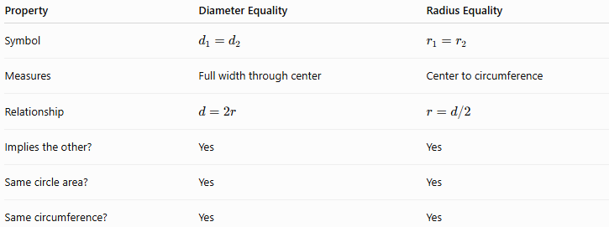
Property | Diameter Equality | Radius Equality
Symbol | $$d_{1}=d_{2}$$ | $$r_{1}=r_{2}$$
Measures | Full width through center | Center to circumference
Relationship | $$d=2r$$ | $$r=d/2$$
Implies the other? | Yes | Yes
Same circle area? | Yes | Yes
Same circumference? | Yes | Yes
They contain essentially the same information for circles.

Diameter Equality vs Segment-Length Equality
# Source: AI Source: Provided by: [Data Path: Persons Table -> ID Column: 1, Name_En Column: Motasem Essam] -> From: [ChatGPT] on [7/25/2026]
A diameter is a special line segment.
Thus:
$$\boxed{\text{Diameter Equality}⊂\text{Segment-Length Equality}}$$
in the sense that diameter equality compares the lengths of special segments.
For example:
$$AB=CD$$
could simply mean two segments have equal lengths.
But if $AB$and $CD$are diameters:
$$\boxed{AB=CD}$$
is specifically Diameter Equality.

Diameter Equality vs Congruence
# Source: AI Source: Provided by: [Data Path: Persons Table -> ID Column: 1, Name_En Column: Motasem Essam] -> From: [ChatGPT] on [7/25/2026]
For circles:
$$\boxed{d_{1}=d_{2} ⟺ C_{1}≅C_{2}}.$$
Thus equal diameters of circles guarantee congruence.
But for arbitrary geometric figures, equal diameters are not enough to establish congruence because many non-circular figures can have a notion of maximum width or other diameter-like measures without being determined by that one measurement.
For ordinary Euclidean circles, however, diameter uniquely determines the circle's size.

Diameter Equality in Geometric Proofs
# Source: AI Source: Provided by: [Data Path: Persons Table -> ID Column: 1, Name_En Column: Motasem Essam] -> From: [ChatGPT] on [7/25/2026]
Example
Suppose $AB$and $CD$are diameters of the same circle.
Since all radii of a circle are equal:
$$OA=OC=r$$
and:
$$OB=OD=r.$$
Therefore:
$$AB=AO+OB=2r$$
and:
$$CD=CO+OD=2r.$$
Hence:
$$\boxed{AB=CD}.$$
This establishes diameter equality using radius equality and segment addition.

Important Diameter Formulas
# Source: AI Source: Provided by: [Data Path: Persons Table -> ID Column: 1, Name_En Column: Motasem Essam] -> From: [ChatGPT] on [7/25/2026]
Diameter from radius
$$\boxed{d=2r}$$
Radius from diameter
$$\boxed{r=\frac{d}{2}}$$
Circumference from diameter
$$\boxed{C=πd}$$
Area from diameter
$$\boxed{A=\frac{πd^{2}}{4}}$$
Diameter from circumference
$$\boxed{d=\frac{C}{π}}$$
Diameter from endpoints
$$\boxed{d=\sqrt{{\left(x_{2}-x_{1}\right)}^{2}+{\left(y_{2}-y_{1}\right)}^{2}}}$$
when the two points are the endpoints of a diameter.

Classification Summary
# Source: AI Source: Provided by: [Data Path: Persons Table -> ID Column: 1, Name_En Column: Motasem Essam] -> From: [ChatGPT] on [7/25/2026]

Diameter Equality
│
├── Direct Equality
│ └── d₁ = d₂
│
├── Radius-Based Equality
│ └── r₁ = r₂ → d₁ = d₂
│
├── Same-Circle Equality
│ └── All diameters of one circle are equal
│
├── Congruence-Based Equality
│ └── Congruent circles → equal diameters
│
├── Symmetry-Based Equality
│ └── Symmetric diameter segments
│
├── Transformation-Based Equality
│ └── Isometries preserve diameter
│
├── Chord-Based Equality
│ └── Equal longest chords → equal diameters
│
├── Coordinate-Based Equality
│ └── Equal calculated diameter lengths
│
├── Algebraic Equality
│ └── Equal diameter expressions
│
└── Circle-Measurement Equality
├── Equal diameter
├── Equal circumference
└── Equal area

Relationship to Geometric Equality
# Source: AI Source: Provided by: [Data Path: Persons Table -> ID Column: 1, Name_En Column: Motasem Essam] -> From: [ChatGPT] on [7/25/2026]
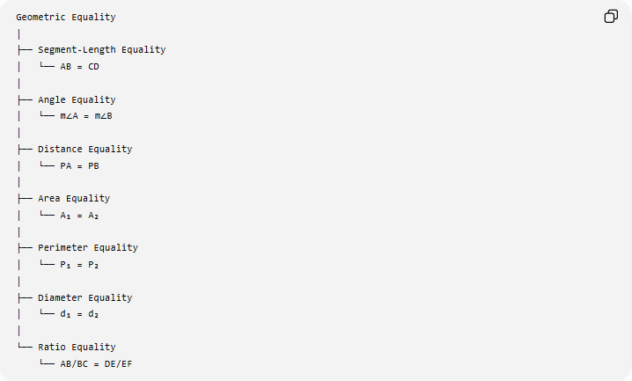
Geometric Equality
│
├── Segment-Length Equality
│ └── AB = CD
│
├── Angle Equality
│ └── m∠A = m∠B
│
├── Distance Equality
│ └── PA = PB
│
├── Area Equality
│ └── A₁ = A₂
│
├── Perimeter Equality
│ └── P₁ = P₂
│
├── Diameter Equality
│ └── d₁ = d₂
│
└── Ratio Equality
└── AB/BC = DE/EF
Diameter Equality is therefore a specialized form of length equality associated with circles.

Key Points
# Source: AI Source: Provided by: [Data Path: Persons Table -> ID Column: 1, Name_En Column: Motasem Essam] -> From: [ChatGPT] on [7/25/2026]
- Diameter Equality means:
$$\boxed{d_{1}=d_{2}}$$
- A diameter is twice the radius:
$$\boxed{d=2r}$$
- Therefore:
$$\boxed{d_{1}=d_{2} ⟺ r_{1}=r_{2}}.$$
- All diameters of the same circle have equal length.
- Equal diameters imply equal radii.
- Equal diameters of circles imply:
$$\boxed{C_{1}=C_{2}}$$
and:
$$\boxed{A_{1}=A_{2}}.$$
- Equal diameters of circles imply the circles are congruent.
- Isometries preserve diameter.
- Scaling changes diameter according to:
$$\boxed{d^{'}=kd}.$$
- Diameter equality is a specialized form of Segment-Length Equality.
- For a circle:
$$\boxed{C=πd}$$
and:
$$\boxed{A=\frac{πd^{2}}{4}}.$$

Conclusion
# Source: AI Source: Provided by: [Data Path: Persons Table -> ID Column: 1, Name_En Column: Motasem Essam] -> From: [ChatGPT] on [7/25/2026]
Diameter Equality is the exact equality between the lengths of two or more diameters:
$$\boxed{d_{1}=d_{2}}.$$
Because the diameter uniquely determines the radius of a circle through $d=2r$, equal diameters are equivalent to equal radii and, for circles, also imply equal circumferences, equal areas, and congruent circles.
$$\boxed{\text{Diameter Equality }⟺\text{ Radius Equality}}$$
and, for circles,
$$\boxed{d_{1}=d_{2}⇒r_{1}=r_{2}⇒C_{1}=C_{2}⇒A_{1}=A_{2}}.$$

